Wild Rydes AWS Project – Step-by-Step Walkthrough

This document provides a detailed walkthrough of deploying the AWS Wild Rydes web application, a serverless ride-sharing app. The project follows a guided AWS tutorial and demonstrates hands-on experience with GitHub, AWS Amplify, Cognito, Lambda, API Gateway, and DynamoDB.

# Step 1: GitHub Setup

The first step was to create a GitHub account and clone the repository containing the Wild Rydes source code. GitHub served as the version control platform for storing, updating, and pulling project code.

# Step 2: AWS Amplify Integration

The GitHub repository was then connected to AWS Amplify with full access. Amplify automatically sets up a CI/CD pipeline that builds and redeploys the application whenever changes are committed to GitHub. This allows for automated deployment and hosting of the web app. Amplify uses a GitHub webhook to detect changes and trigger a new deployment.

# Step 3: User Authentication with Amazon Cognito

To implement user authentication, Amazon Cognito was used. A new user pool was created, and the User Pool ID and Client ID were copied and added to the `config.js` file in the GitHub repository. After committing these changes, Amplify redeployed the app. Visiting the site and clicking 'Giddy Up' directed users to the sign-in page. After account creation, a verification code was sent via email. Once verified, users could successfully log in.

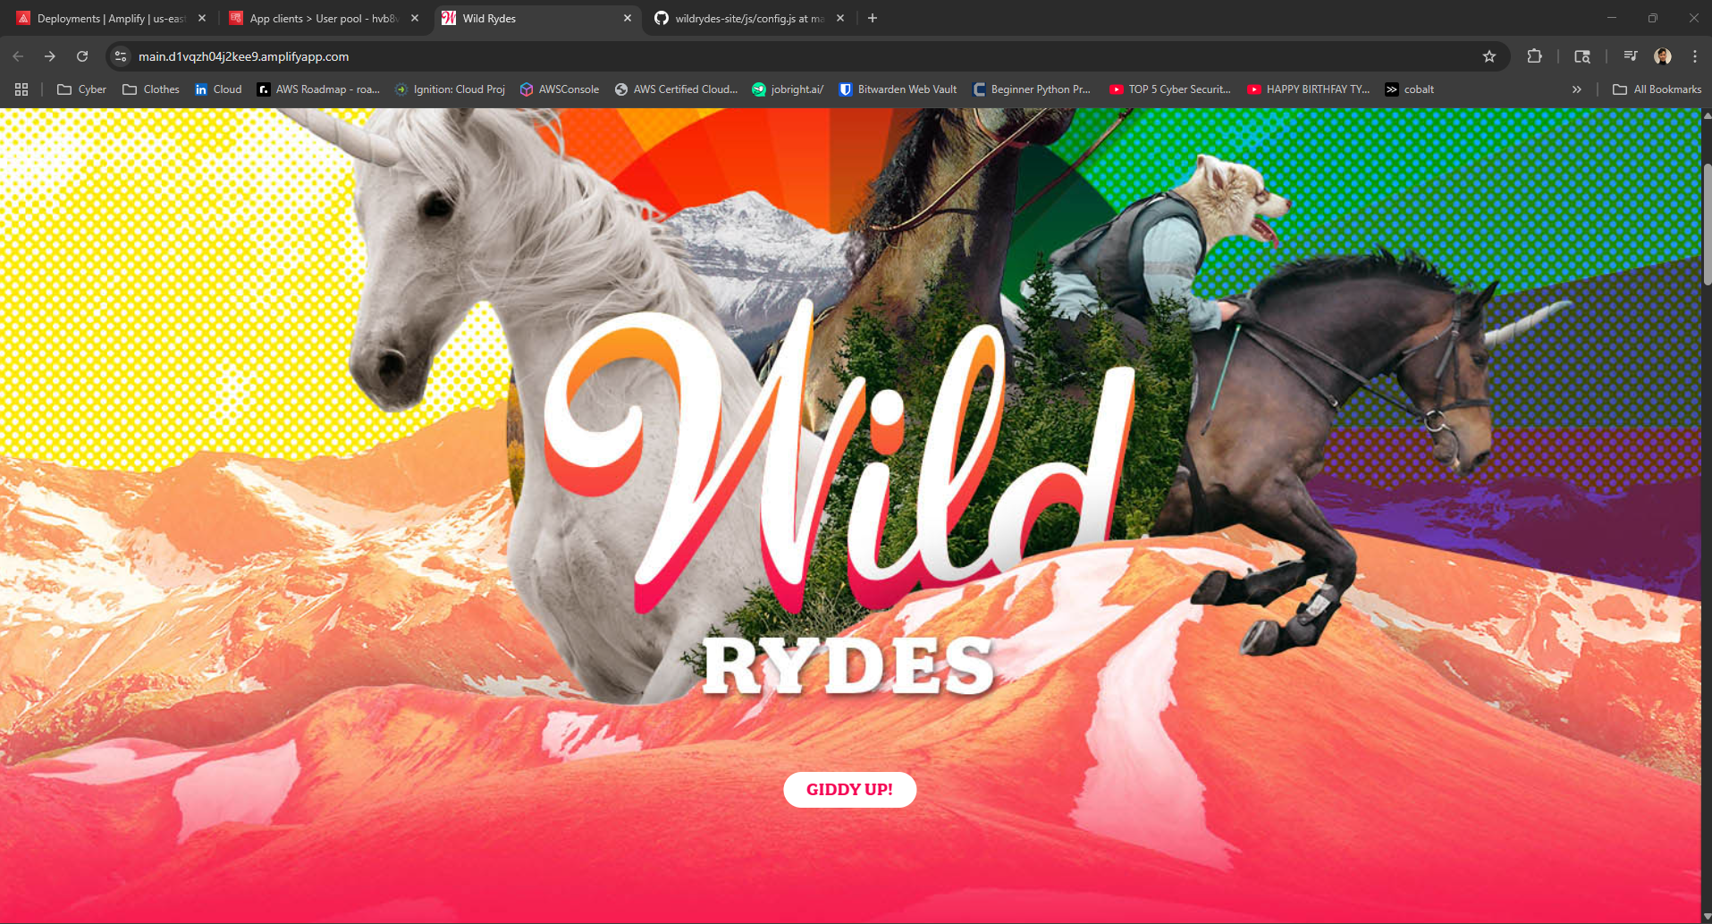

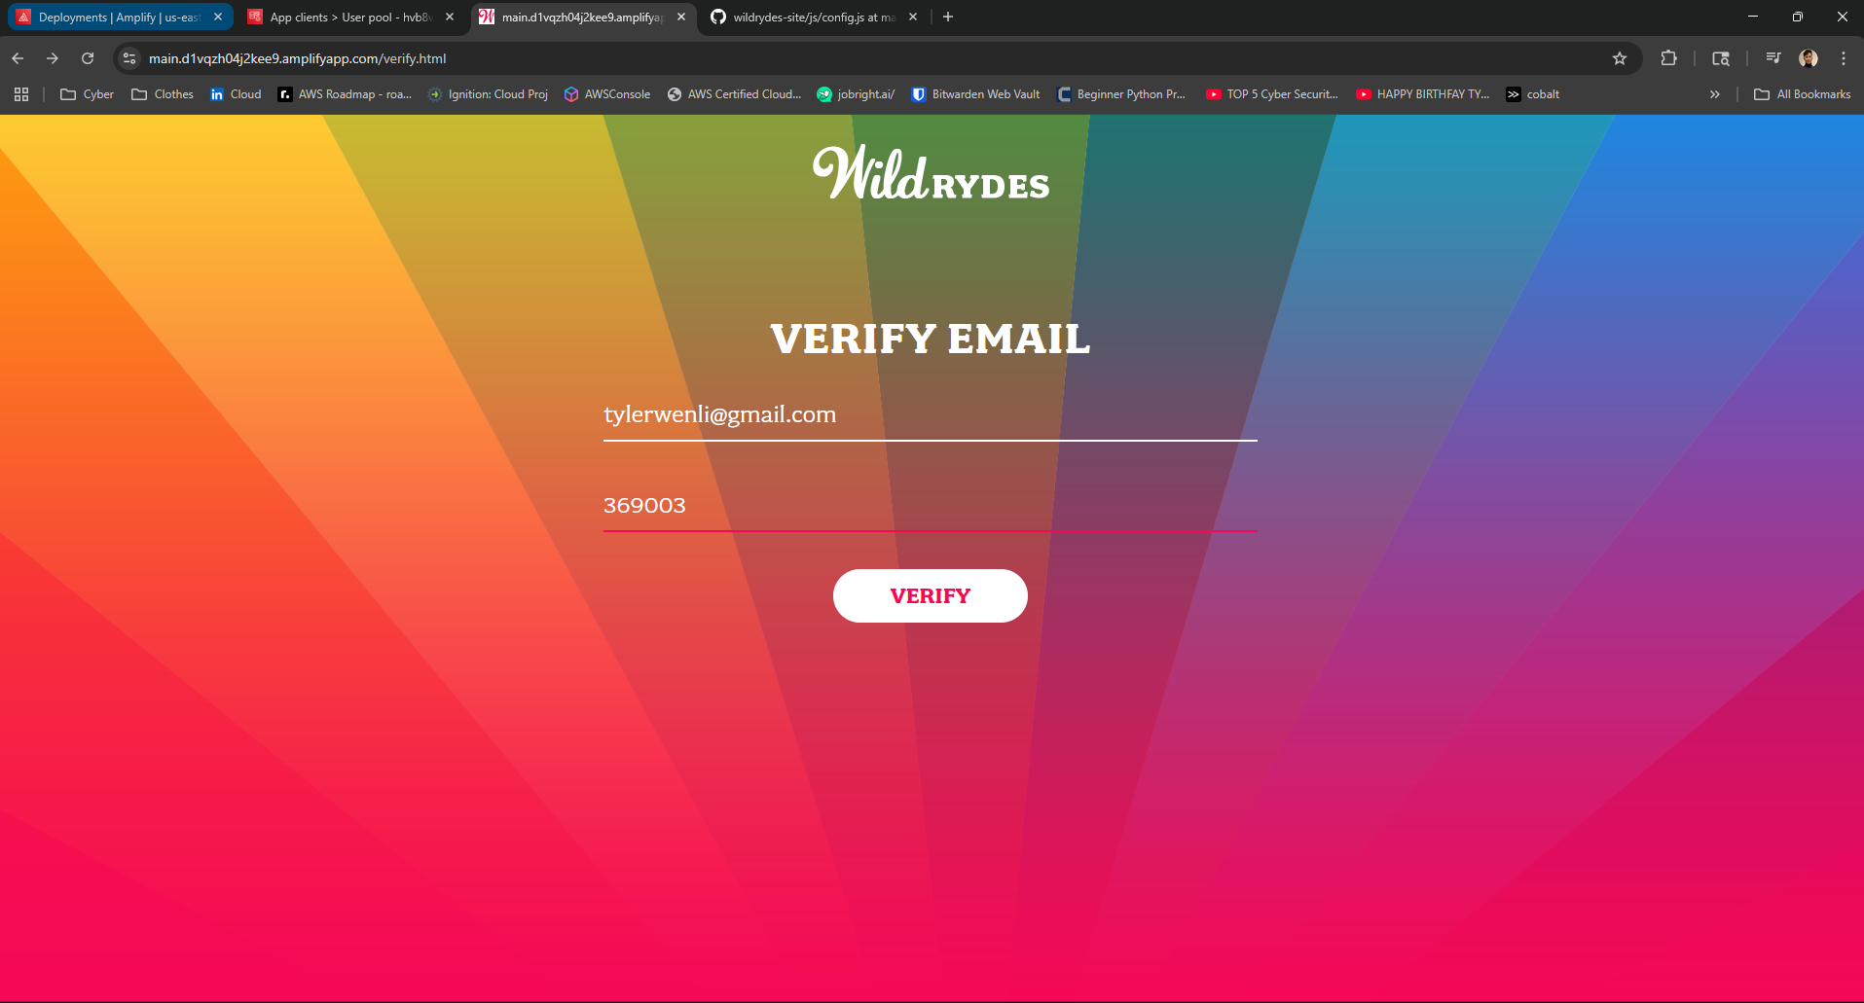

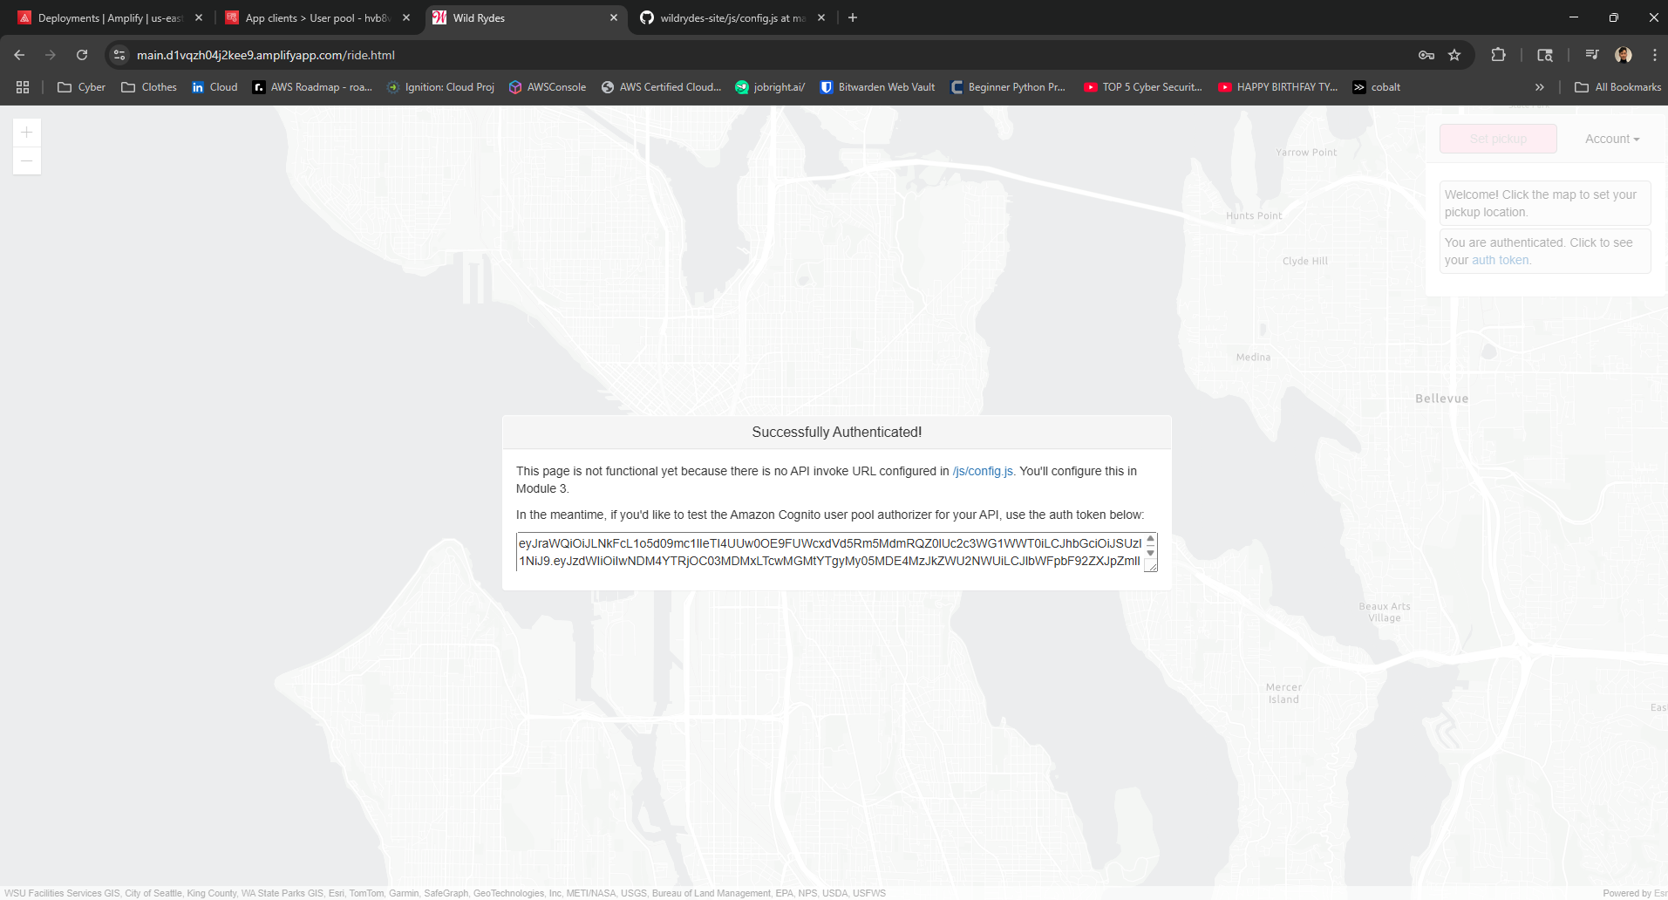

# Step 4: Enabling Backend Logic with Lambda and DynamoDB

To handle ride request functionality, AWS Lambda was used to execute backend logic in response to events. A new DynamoDB table was created to store ride data. An IAM policy named `DynamoDBWriteAccess` was created to grant write access. A Lambda function was created and populated with code from the tutorial. Once deployed, a test event was configured and executed. A successful response returned a status code of 201.

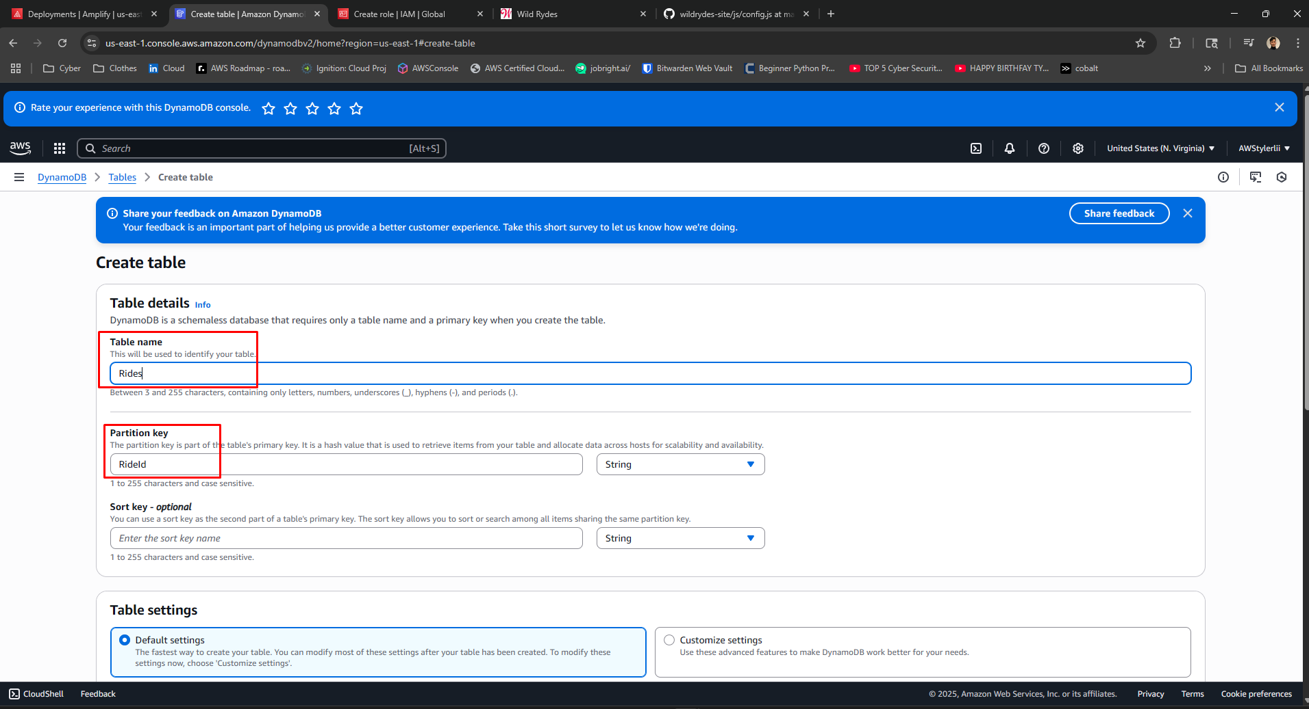

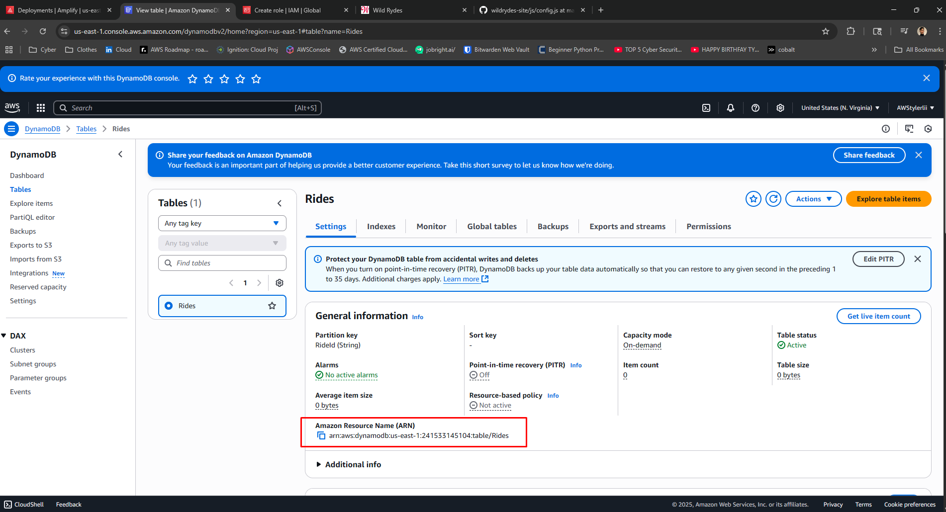

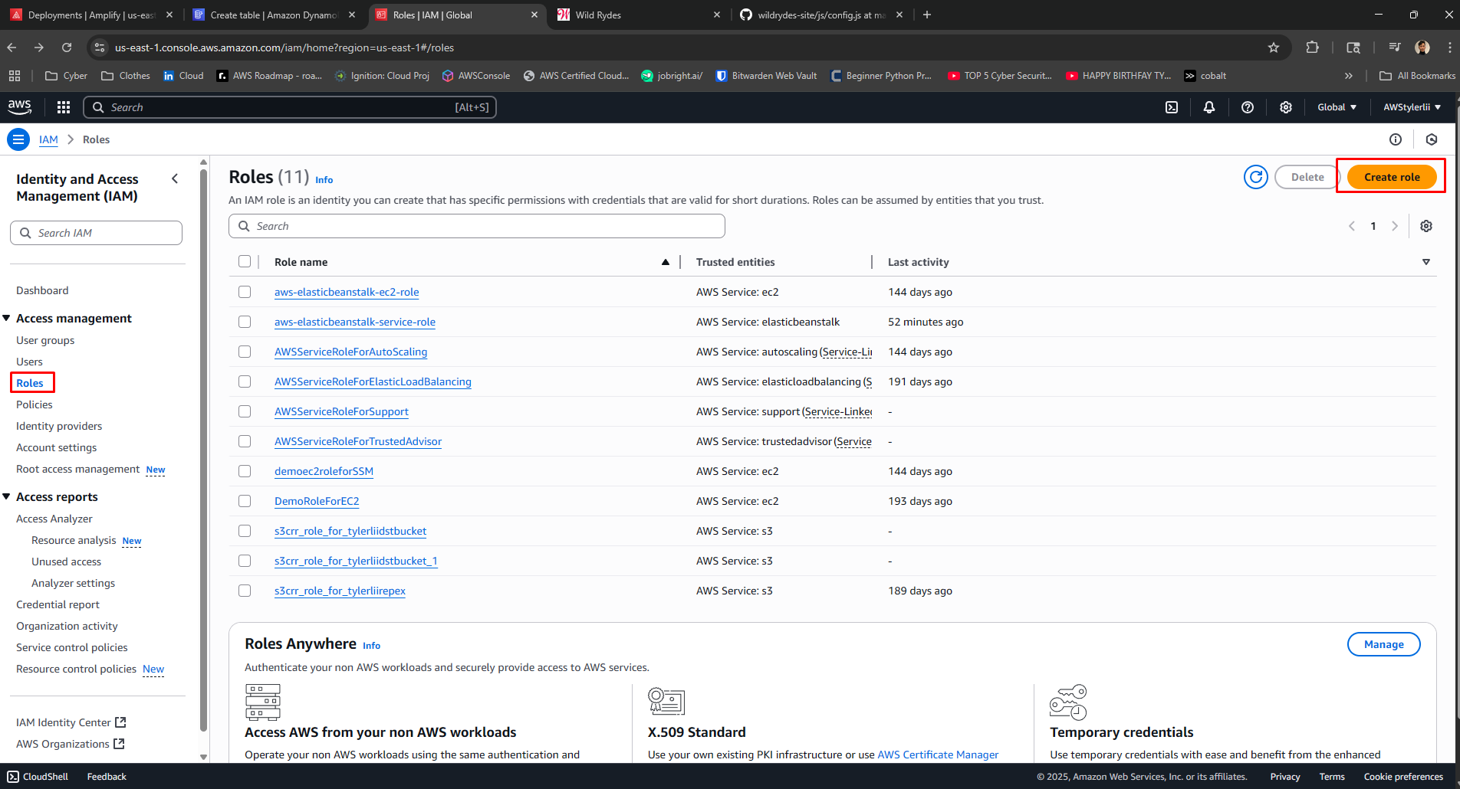

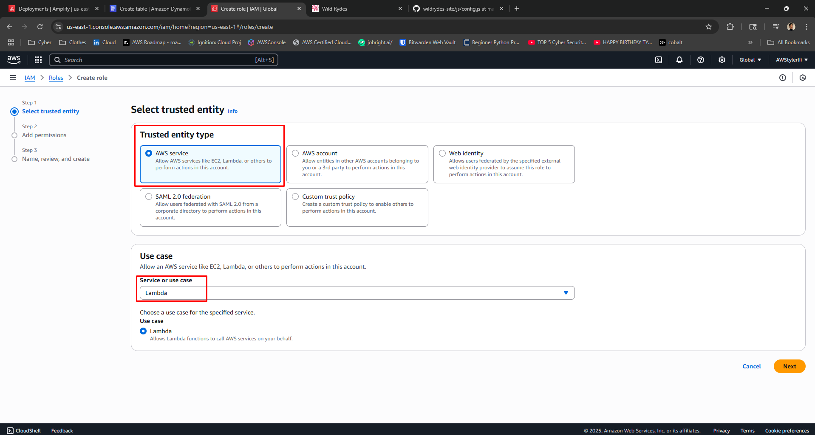

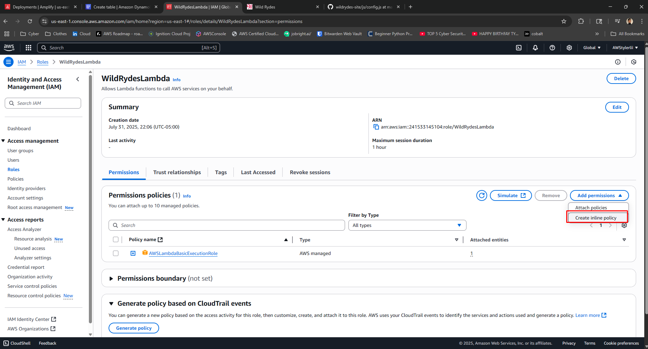

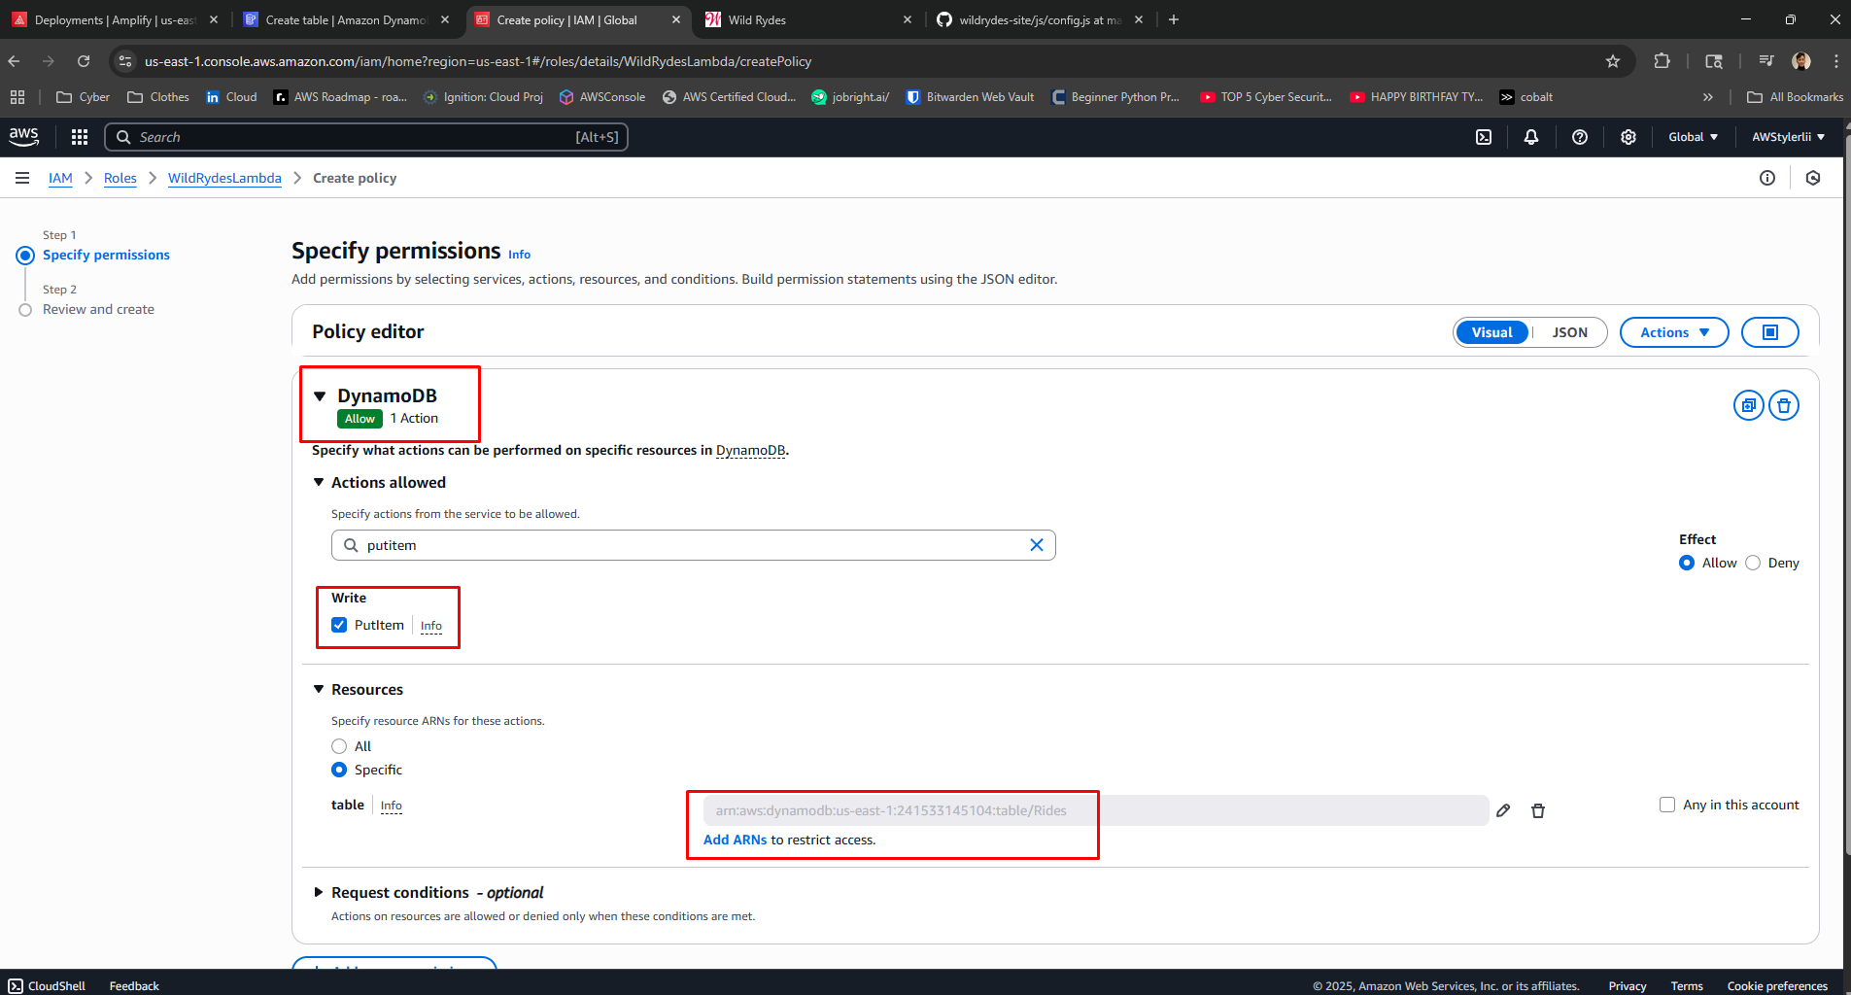

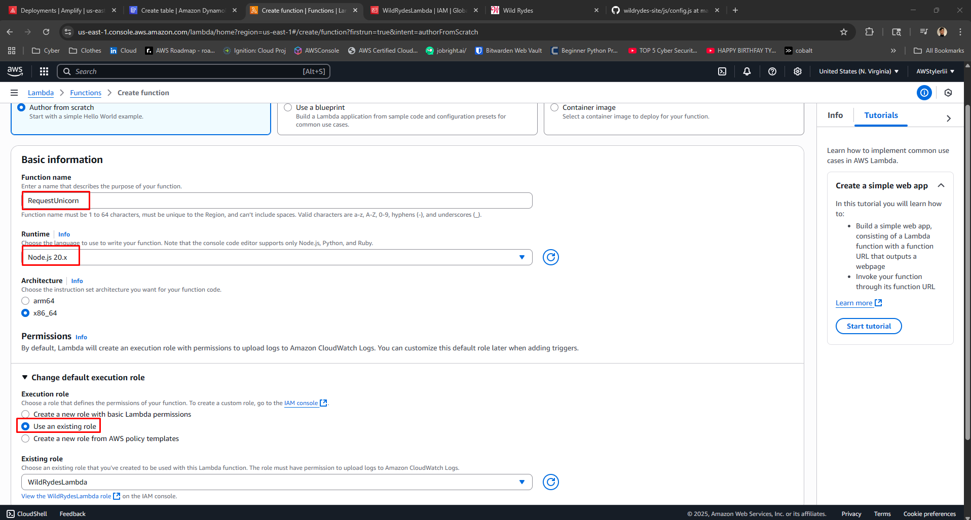

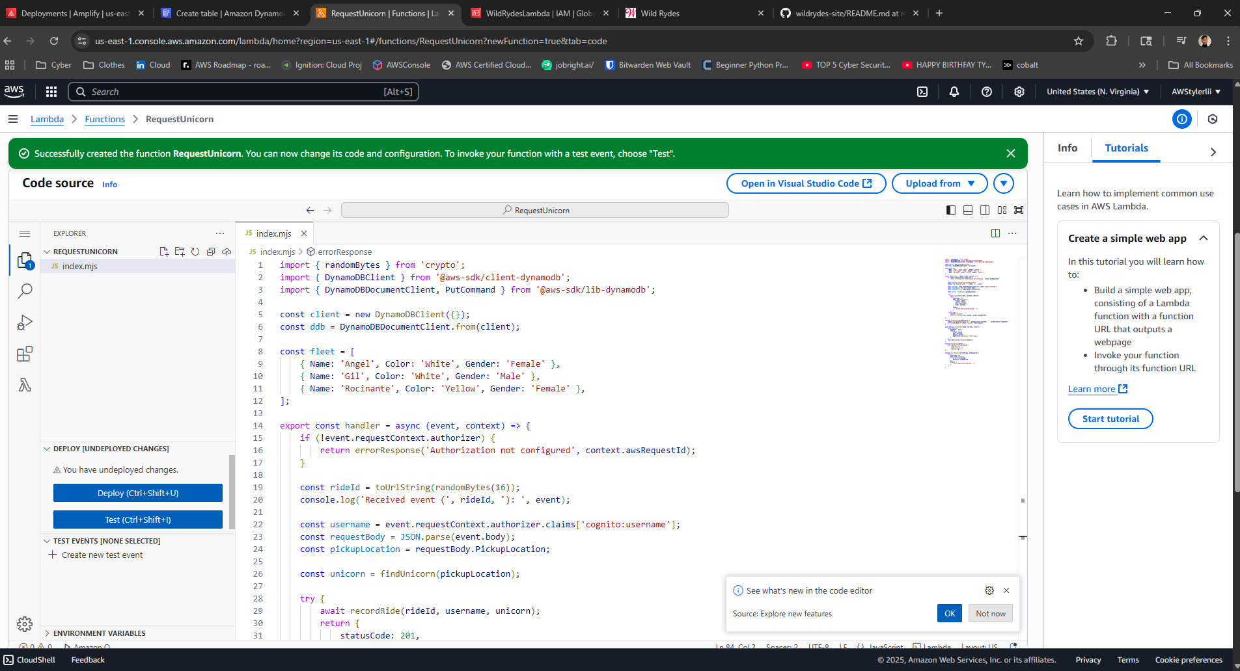

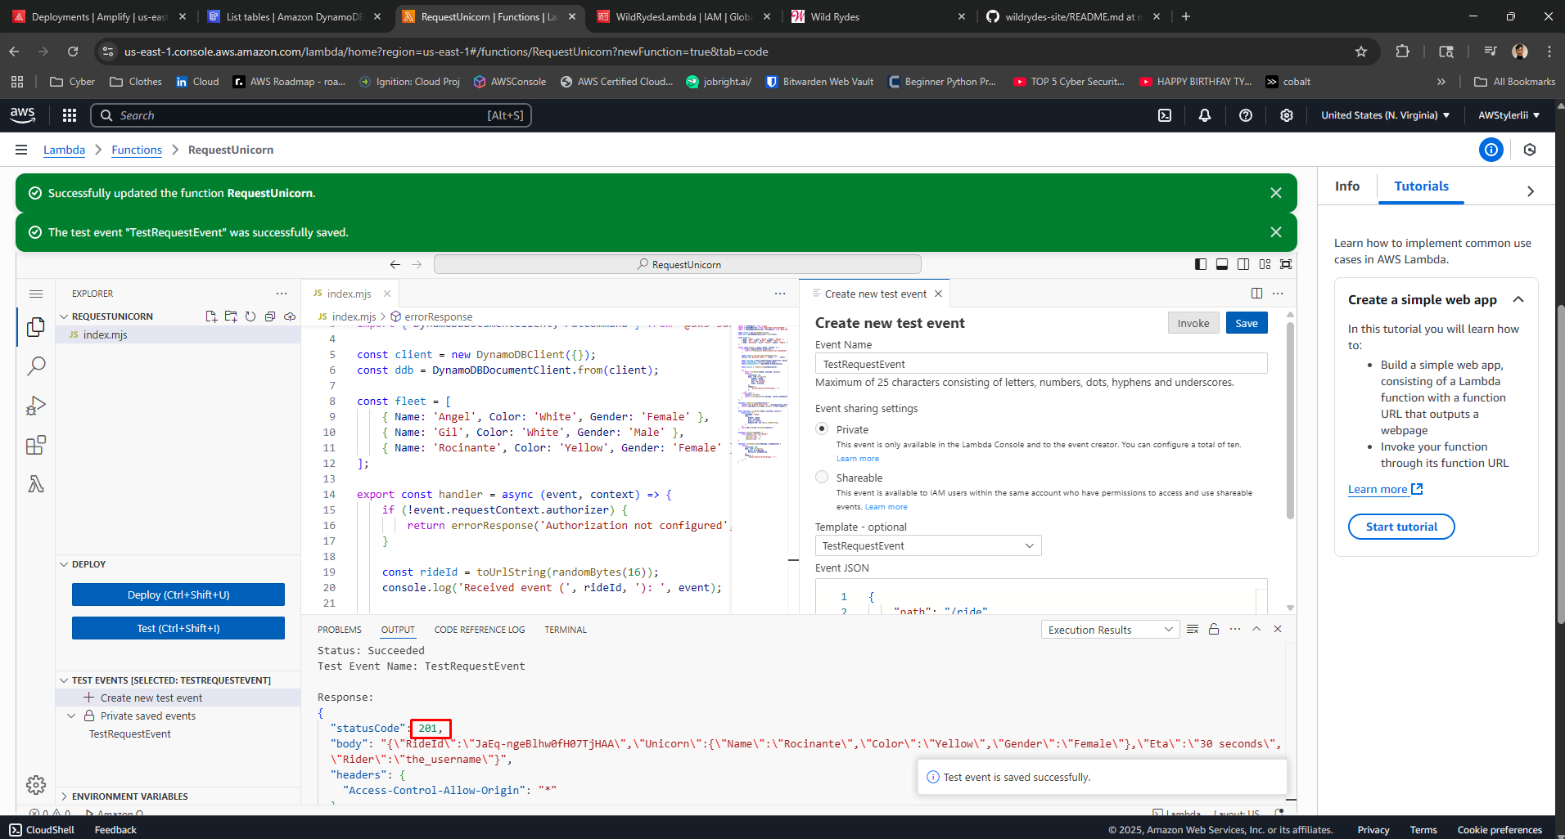

# Step 5: Setting Up API Gateway

An API was created using Amazon API Gateway with the REST API option. A custom authorizer was tested by pasting a valid token into the test interface, expecting a 200 status code response. A new resource and POST method were created and integrated with the Lambda function. After deploying the API, the invoke URL was copied and added to the `config.js` file in GitHub, which triggered another redeployment via Amplify.

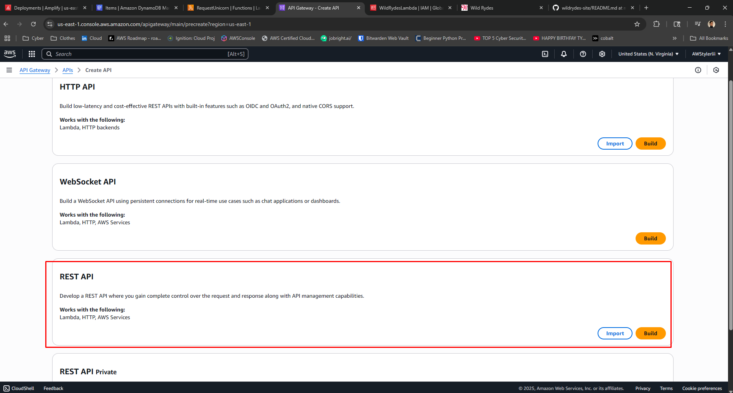

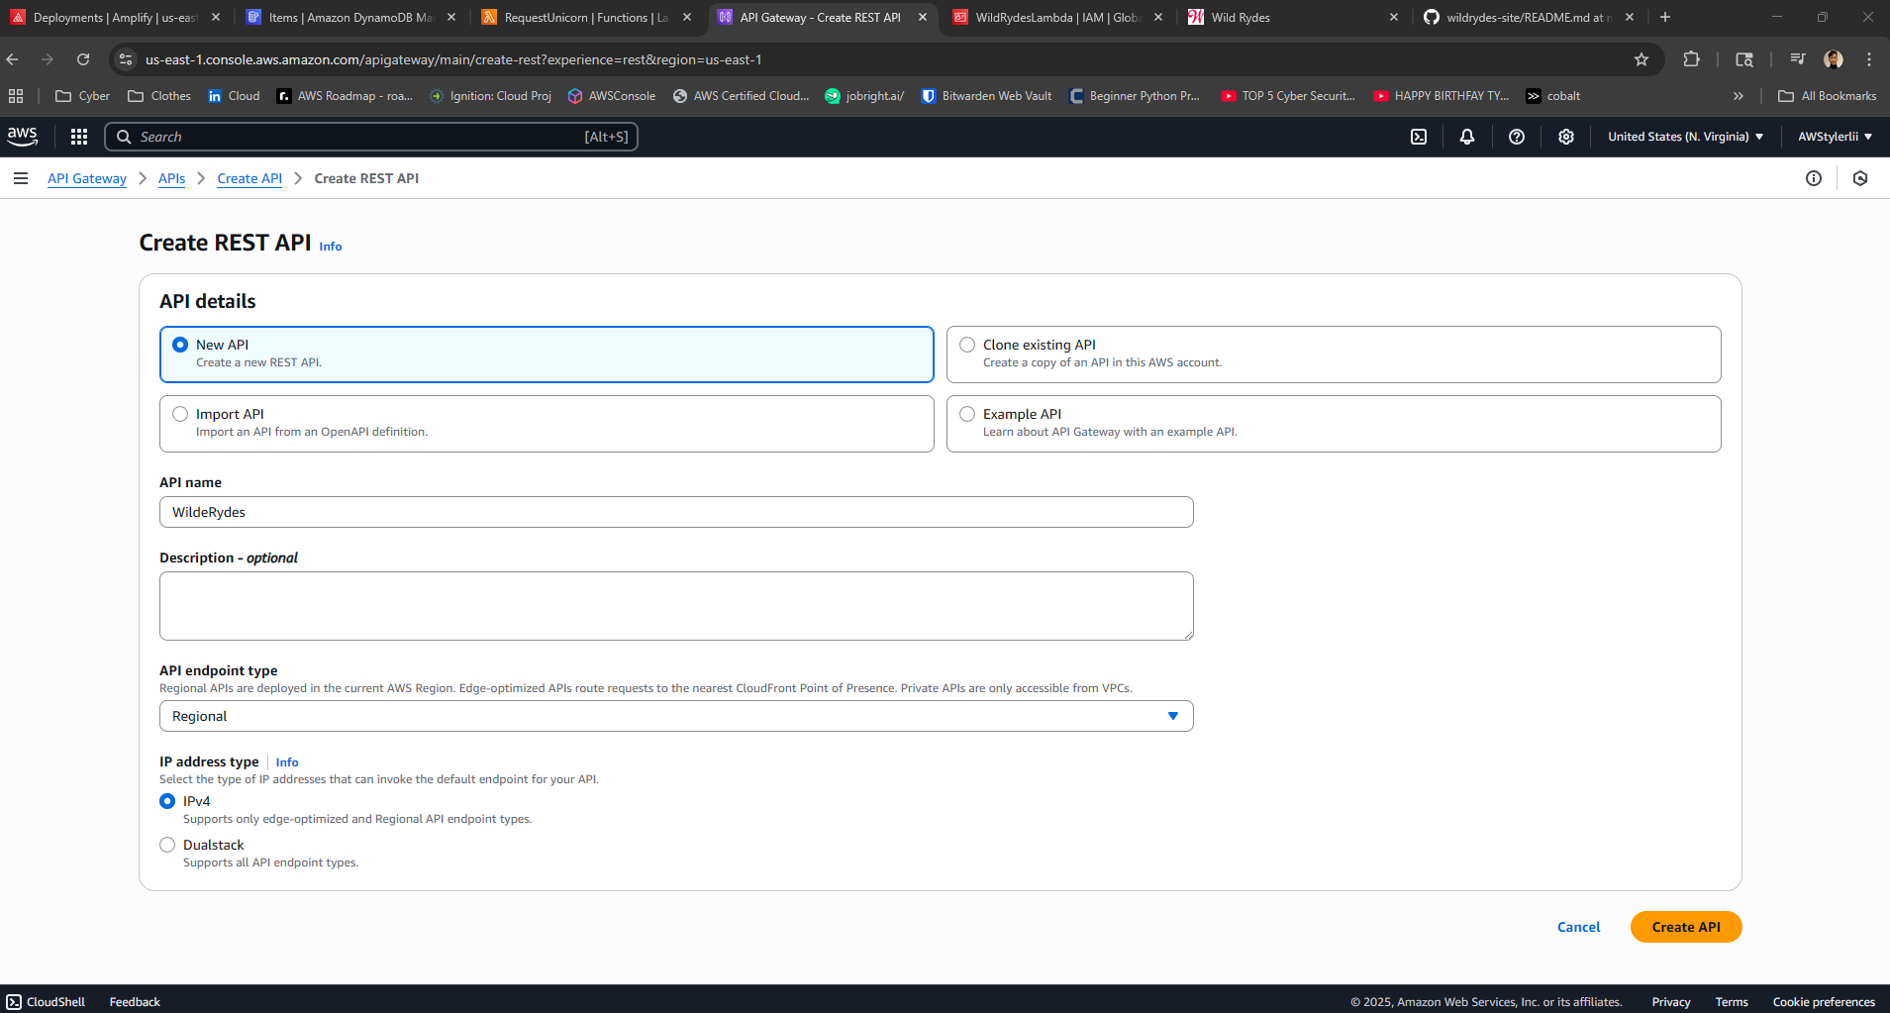

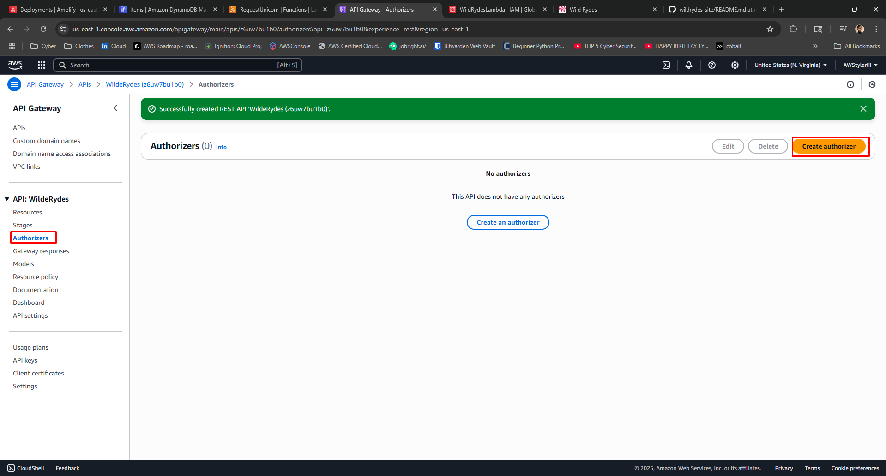

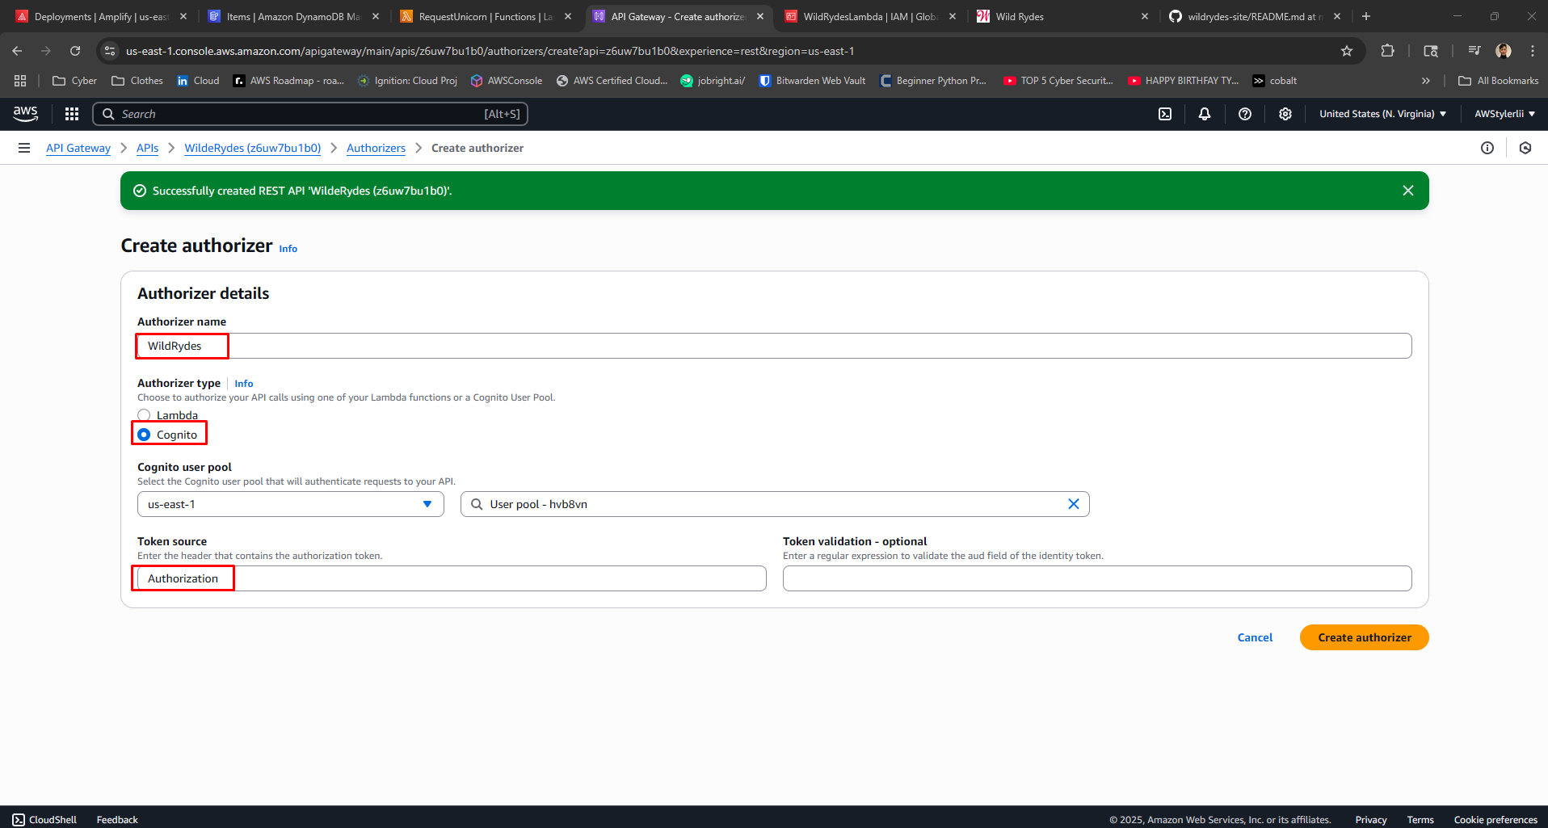

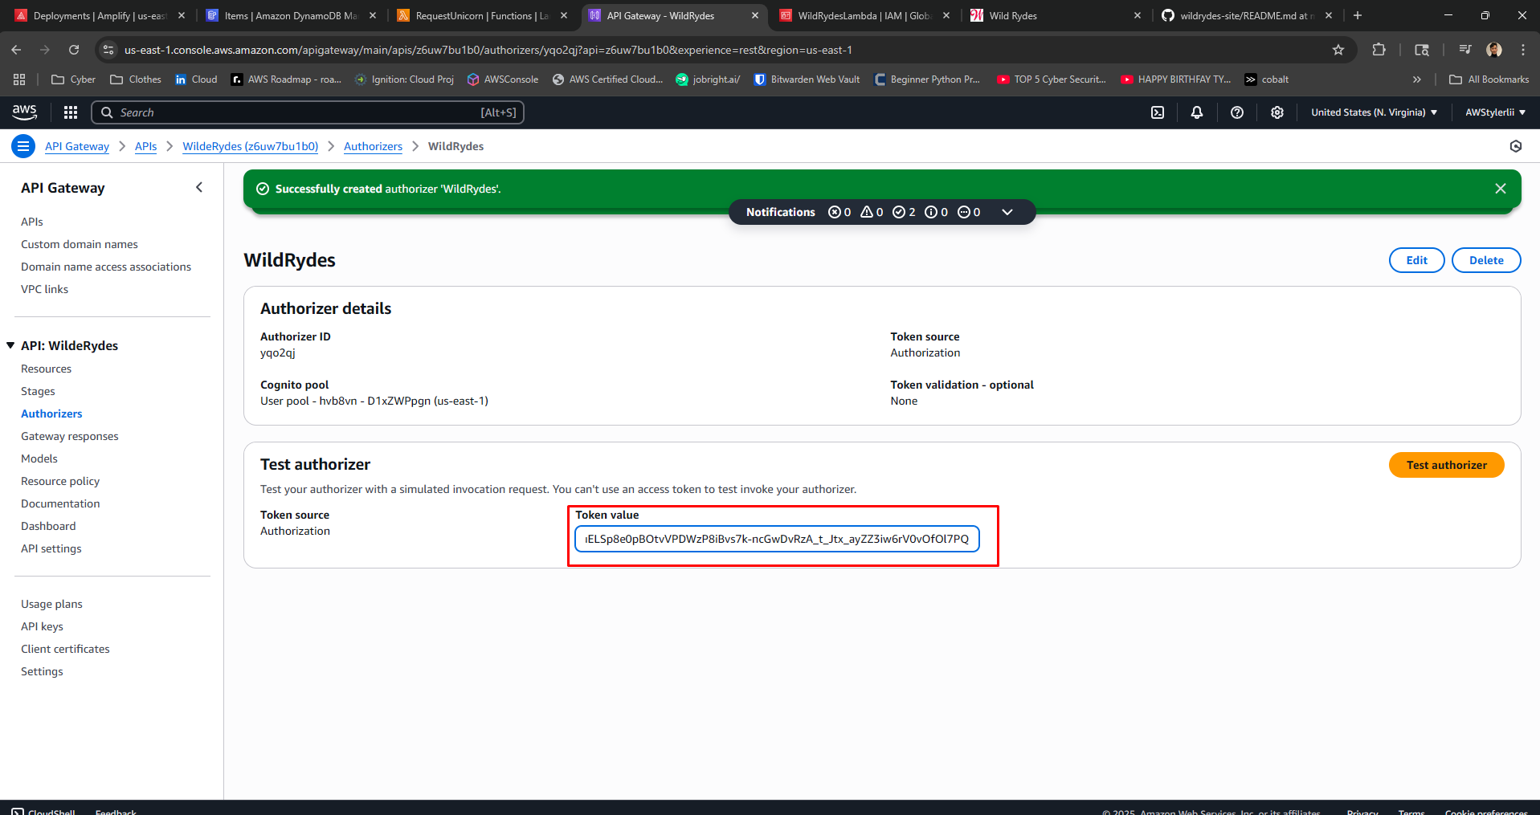

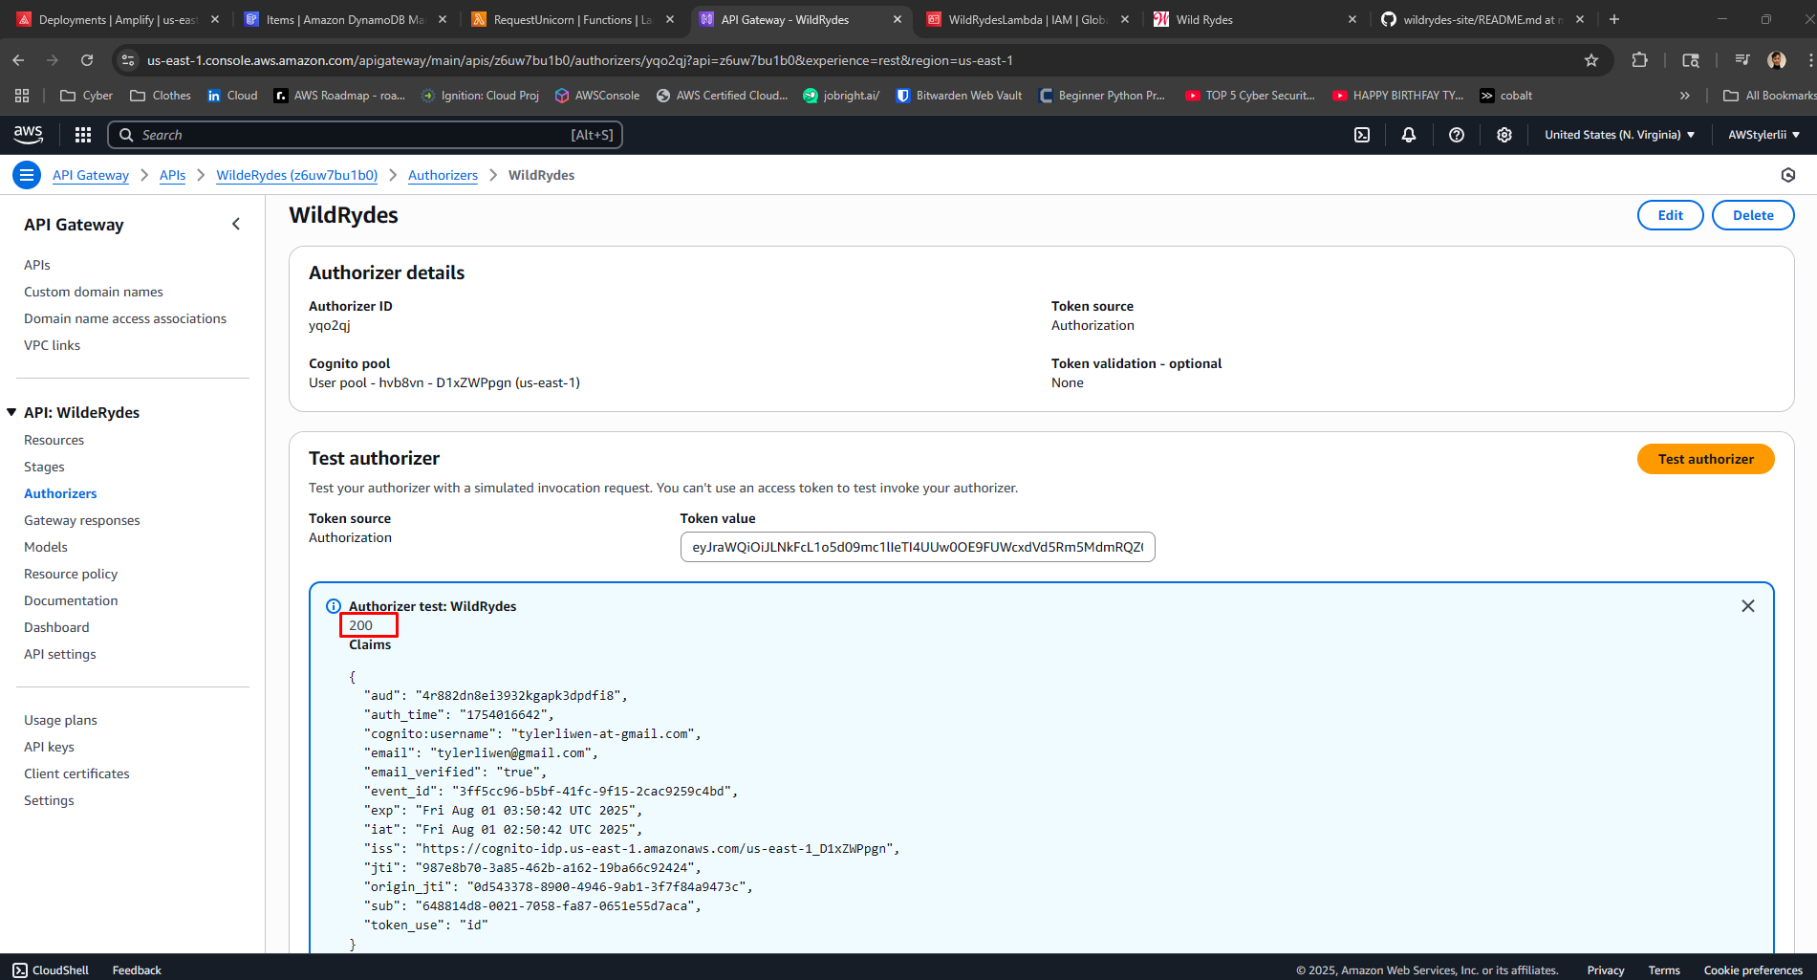

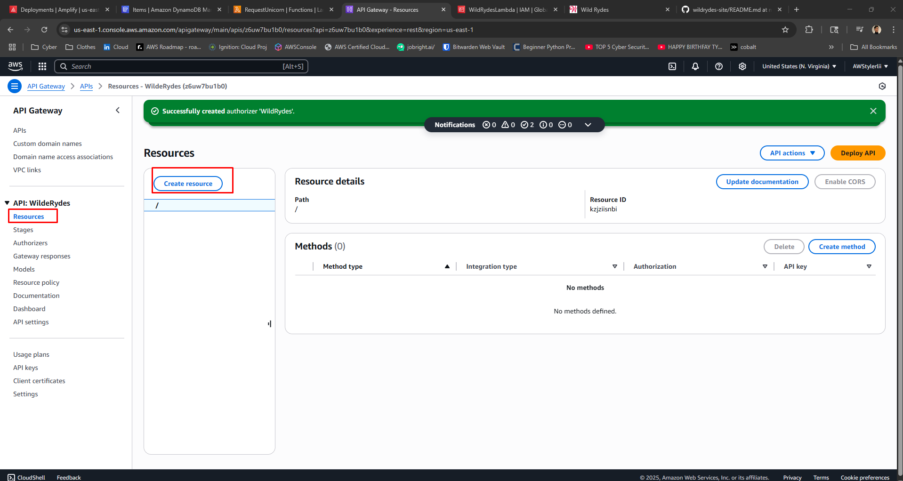

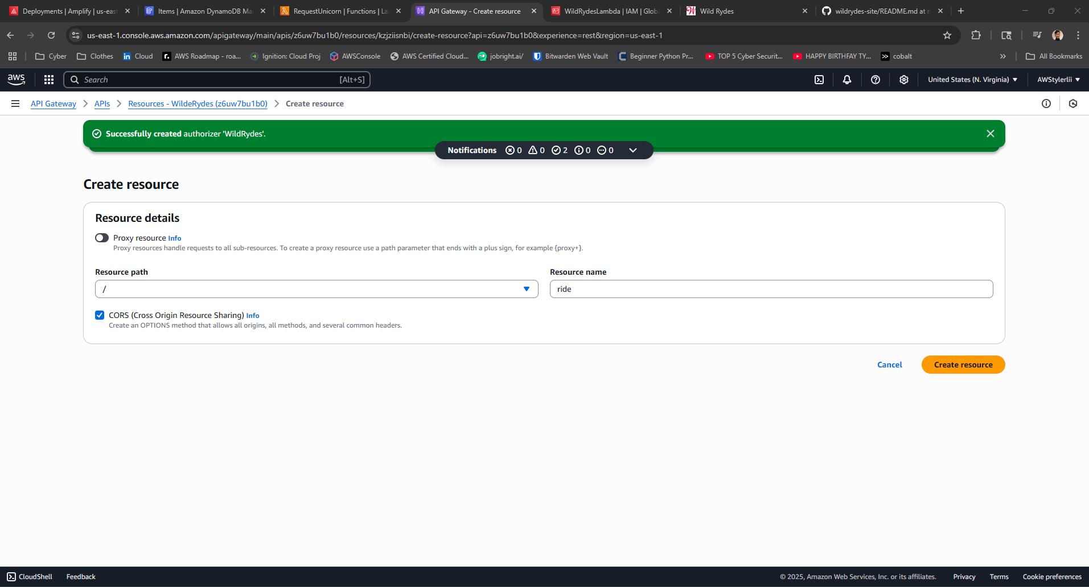

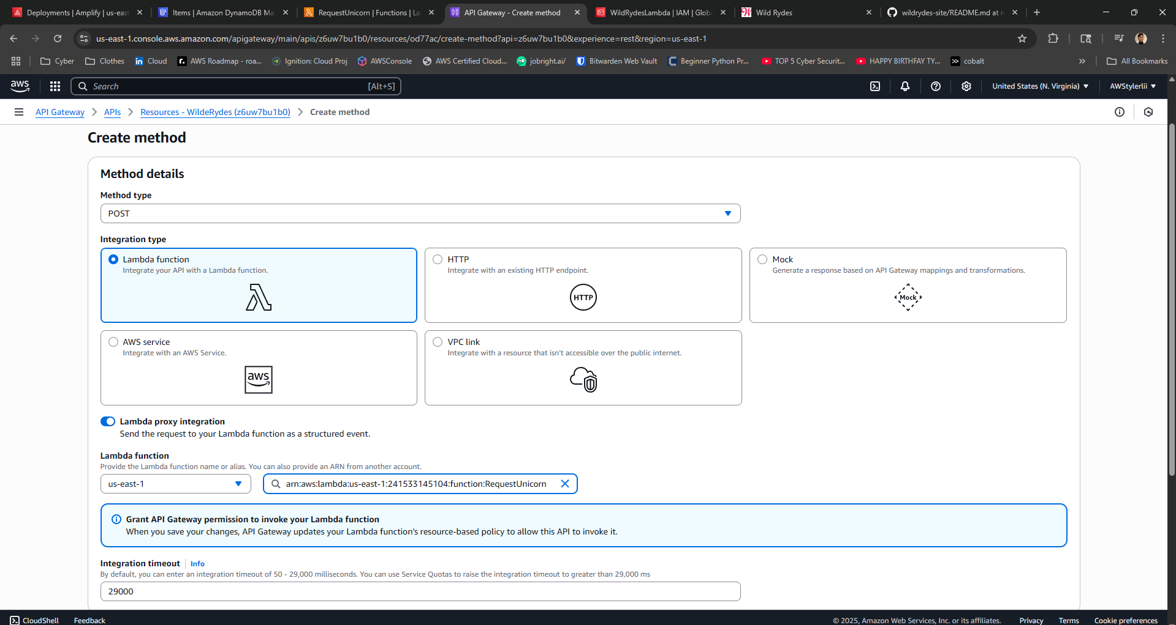

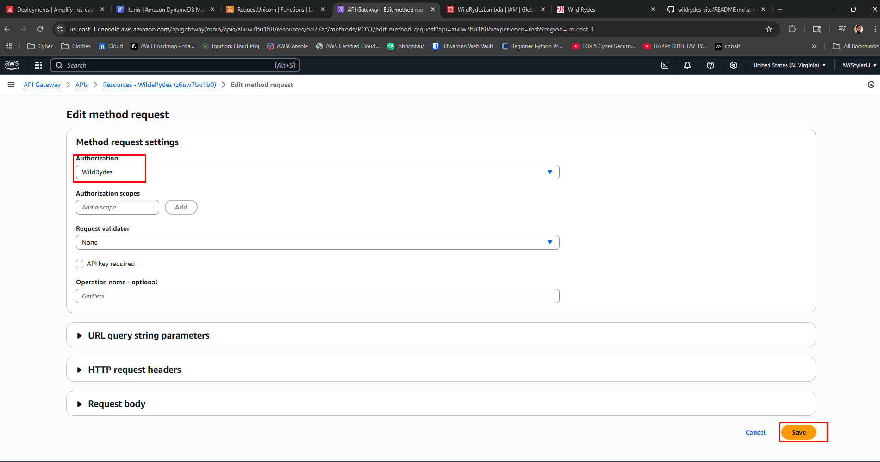

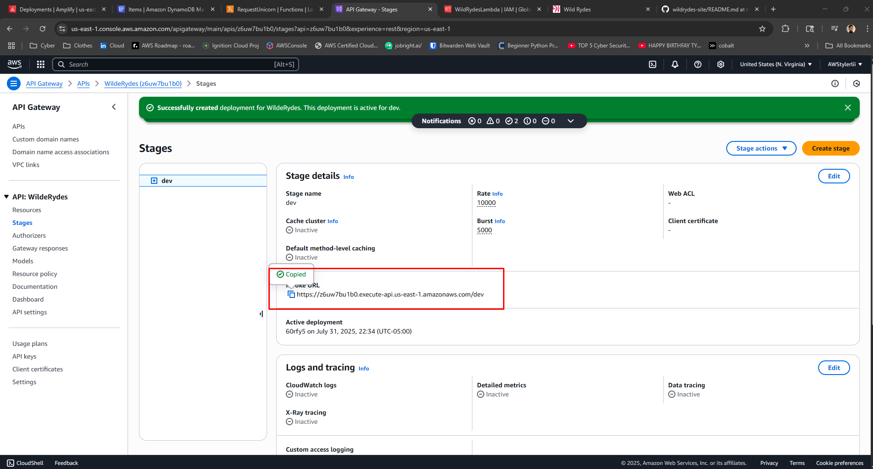

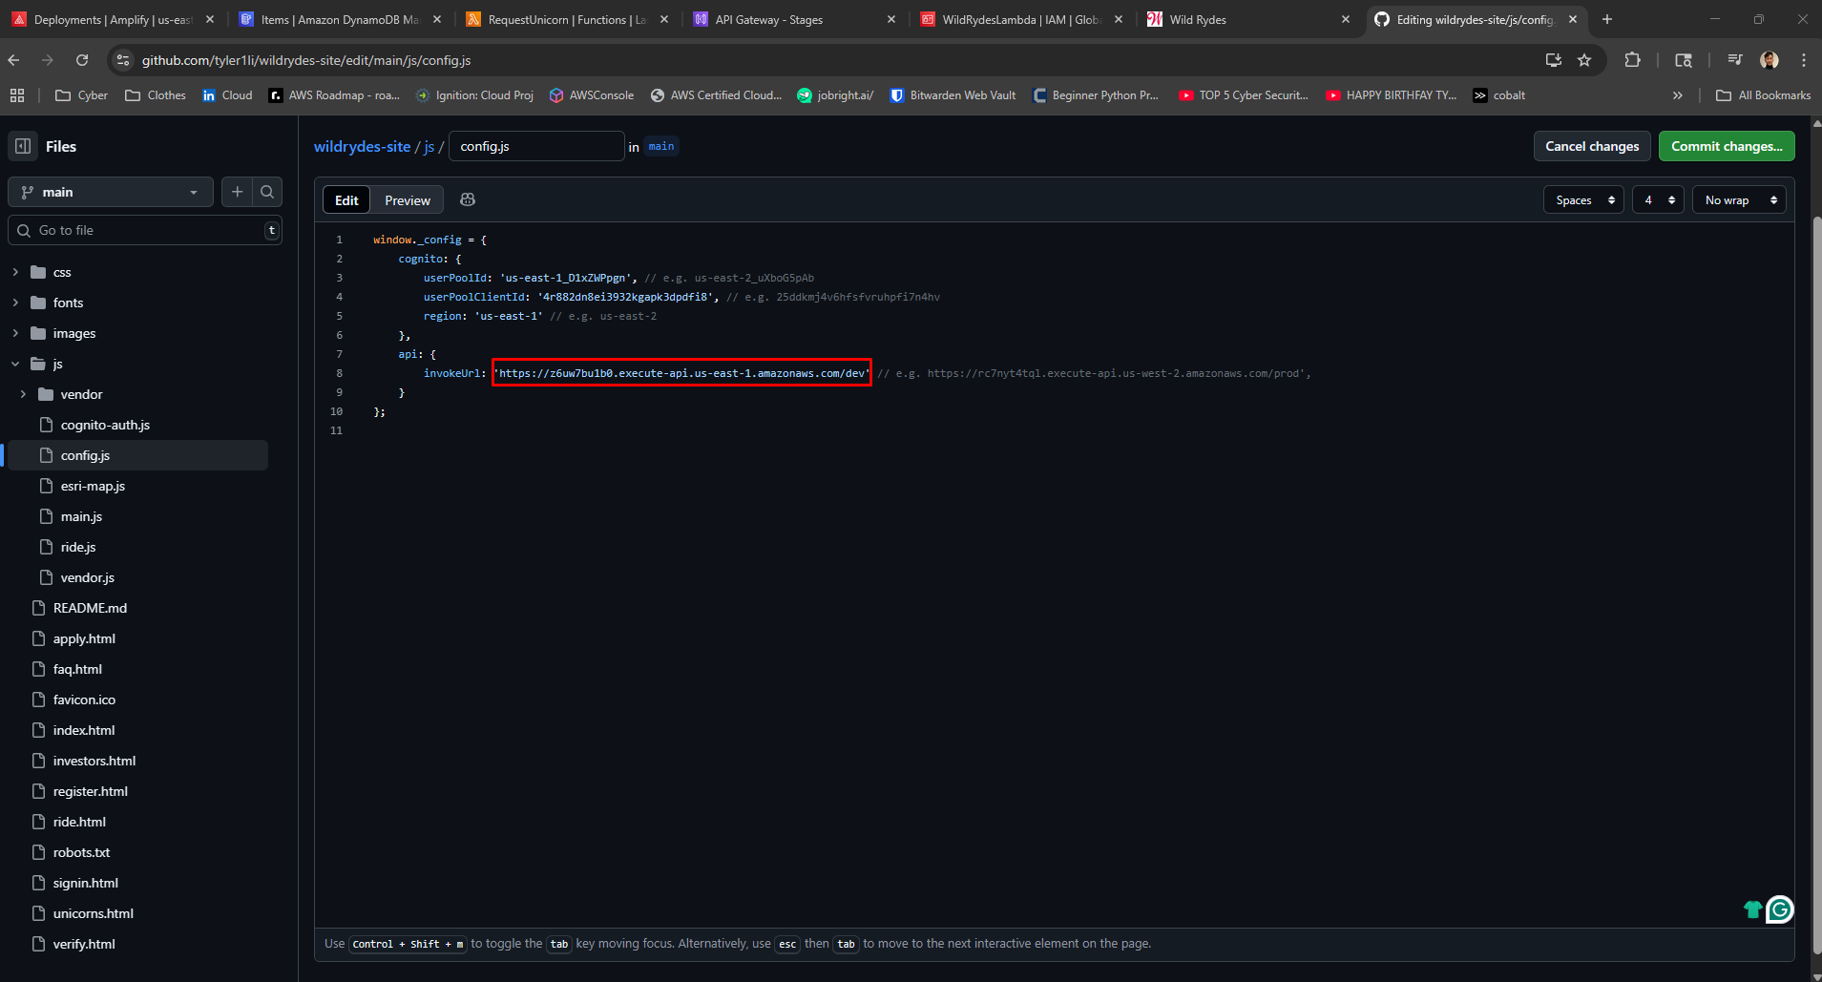

# Step 6: Final Testing

The final test was conducted by visiting the deployed application at https://main.d1vqzh04j2kee9.amplifyapp.com/ride.html. After logging in, selecting a location on the map sent a ride request. The request triggered the Lambda function, storing ride data in DynamoDB. The results could be viewed directly from the DynamoDB console.

